Set 17: Employee Performance Analysis

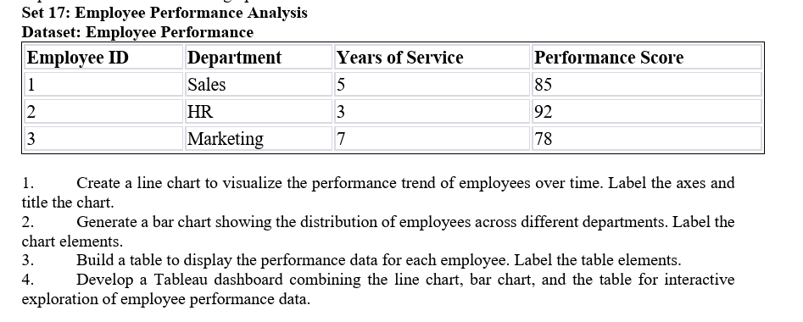

Question 1: Create a line chart to visualize the performance trend of employees over time. Label the axes and title the chart.

AIM
To create a line chart in R to visualize employee performance scores based on their years of service.

CODE
# Employee Performance Data
years <- c(5, 3, 7)
score <- c(85, 92, 78)

# Line Chart
plot(years, score,
type = "o",
col = "blue",
pch = 16,
main = "Employee Performance Trend",
xlab = "Years of Service",
ylab = "Performance Score")

OUTPUT:
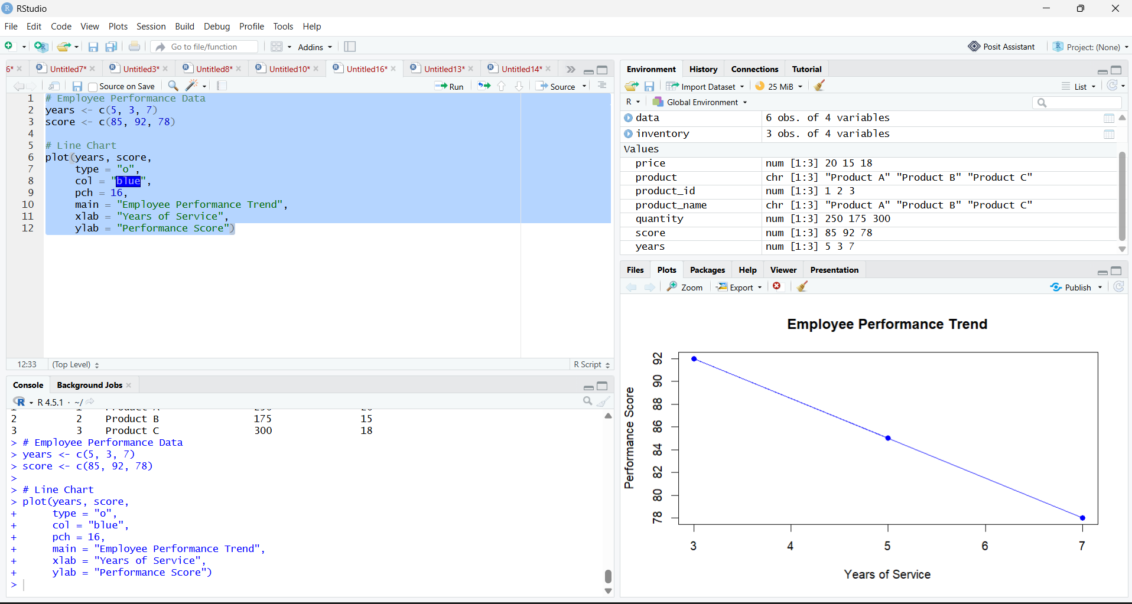

RESULT
Thus, a line chart was created to visualize the relationship between years of service and employee performance scores.

Question 2: Generate a bar chart showing the distribution of employees across different departments. Label the chart elements.

AIM
To create a bar chart in R to display the number of employees in different departments.

CODE
# Employee Department Data
department <- c("Sales", "HR", "Marketing")
employees <- c(1, 1, 1)

# Bar Chart
barplot(employees,
names.arg = department,
col = c("skyblue", "orange", "lightgreen"),
main = "Employee Distribution by Department",
xlab = "Department",
ylab = "Number of Employees")

OUTPUT:
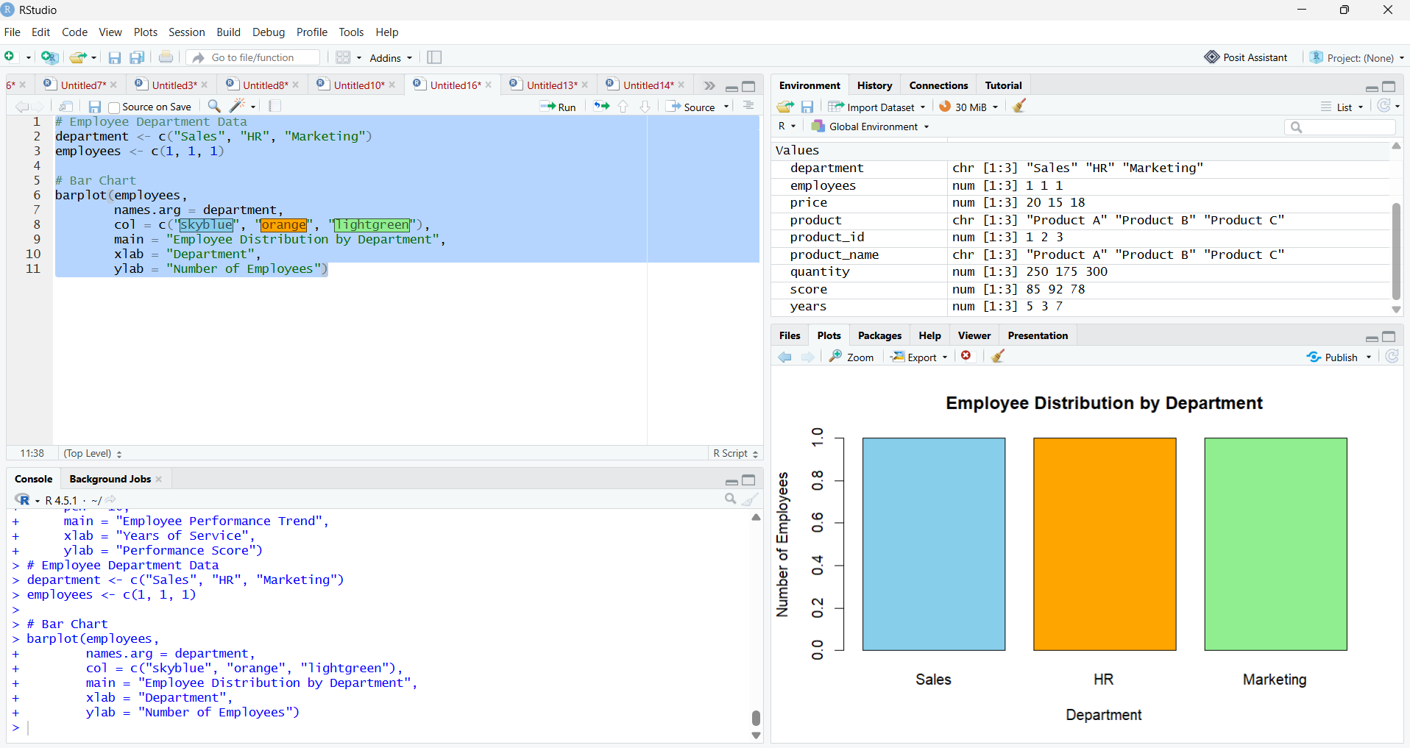

RESULT
Thus, a bar chart was created to show the distribution of employees across the Sales, HR, and Marketing departments.

Question 3: Build a table to display the performance data for each employee. Label the table elements.

AIM
To create a table in R displaying employee ID, department, years of service, and performance score.

CODE
# Employee Performance Dataset
employee_id <- c(1, 2, 3)
department <- c("Sales", "HR", "Marketing")
years_service <- c(5, 3, 7)
performance_score <- c(85, 92, 78)

# Create Table
employee <- data.frame(
Employee_ID = employee_id,
Department = department,
Years_of_Service = years_service,
Performance_Score = performance_score
)

# Display Table
print(employee)

OUTPUT

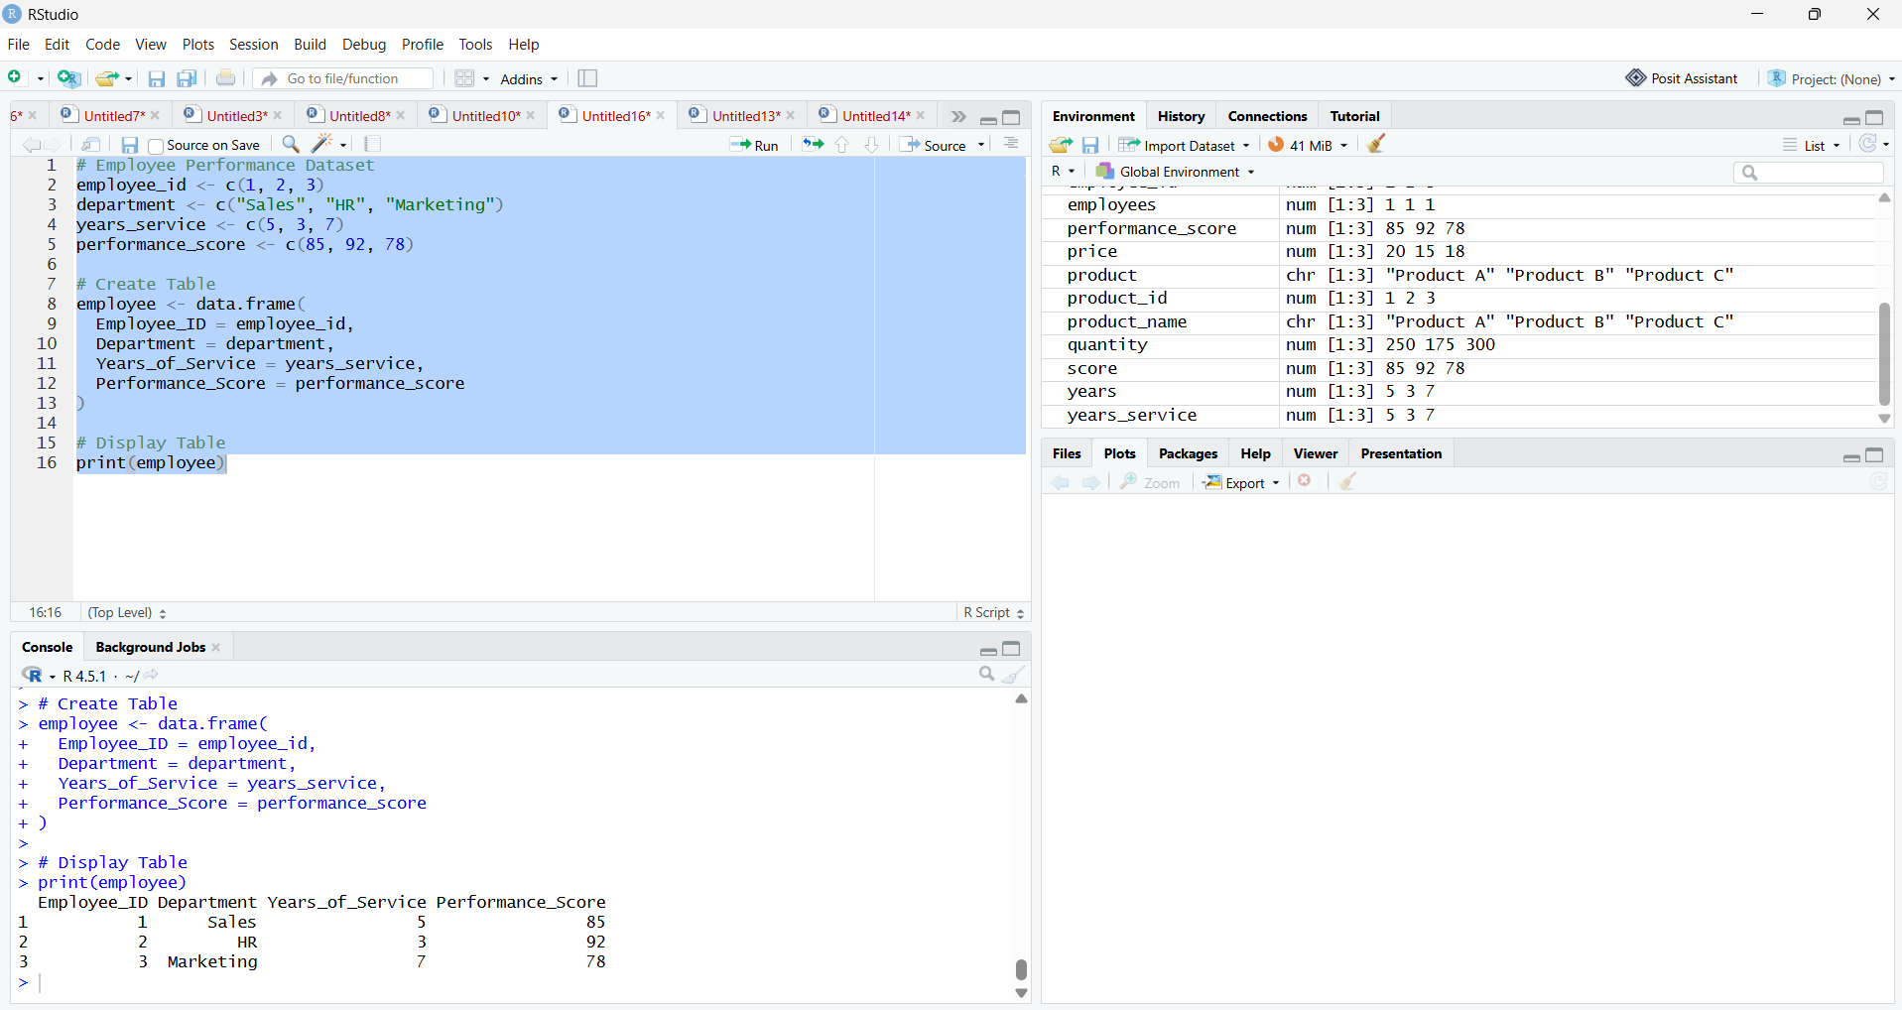

RESULT
Thus, an employee performance table was created successfully with all the required details.

Question 4: Develop a Tableau dashboard combining the line chart, bar chart, and table for interactive exploration of employee performance data.

AIM
To develop an interactive Tableau dashboard combining a line chart, bar chart, and employee performance table.

OUTPUT:
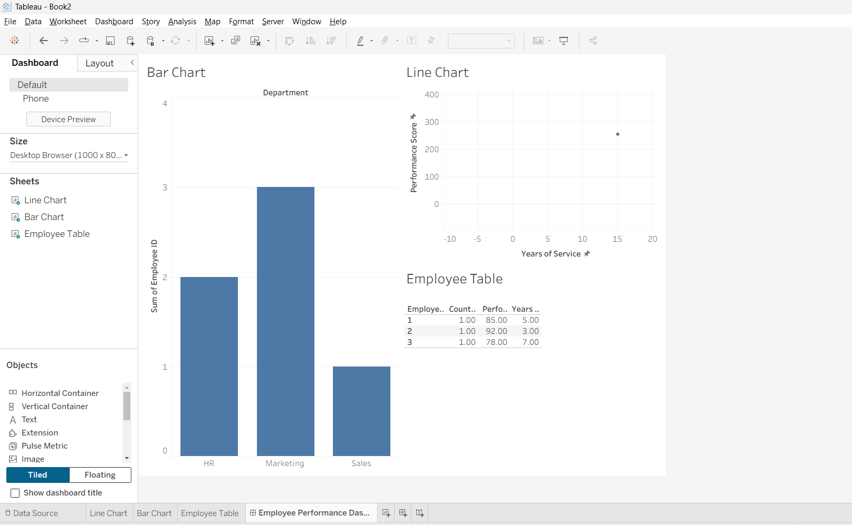

RESULT
Thus, an interactive Tableau dashboard was developed by combining a line chart, bar chart, and employee performance table to explore employee performance scores, years of service, and department distribution.

